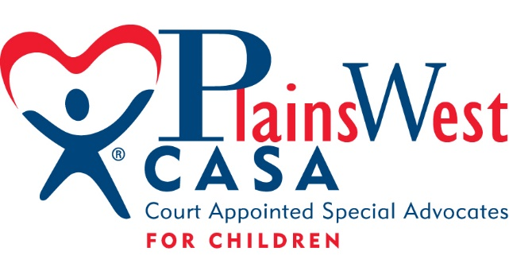

Board of Directors Nominee Application Form
The information you provide is voluntary and will only be used for the purpose of determining an appropriate fit for membership on the Board of Directors of the PlainsWest CASA Program. The information will be shared only with members of the CASA Board of Directors and staff and will be kept in confidence. Statistical and demographic data will be used only in aggregate form.

Full Name:
Business: Home:
Title: Street:
Organization: City:
Street: State/Zip:
City: Phone:
State/Zip: Email:
Phone: Fax:
Spouse/partner name:
Child/ren name(s):
Which address do you prefer we use? Home Business
Gender: Female Male
Birthday:

EDUCATIONAL DATA:
School Degree Year
__________________________________ ___________________________________________________
__________________________________ ___________________________________________________
__________________________________ ___________________________________________________
Are you presently attending school? Yes No If yes, where? Area of study
Do you have any special skills or licenses? Yes No If yes, please explain/describe __________________________________ ___________________________________________________
__________________________________ ___________________________________________________

Current/past occupations:

Current/past community or civic involvement:

Other affiliations including non-profits, civic, professional, and social organizations:

Professional, educational, or personal accomplishments:

Area(s) of personal or professional interest:

Why are you interested in being a member of the CASA Board of Directors?

What do you think you will like best about being a CASA board member?

What area of CASA work interests you the most?
Administration/management Communications/public relations
Community Awareness Finances
Legislation/public policy New program starts
Personnel Program standards/quality assurance
Resource Development Strategic planning
Training/program Other

What responsibilities are you willing/able to accept as a board member?

Do you have family members or friends who are involved with CASA? If so, please list their names and involvement:

Any additional information you wish to share?

Please check any area(s) of expertise you bring to the board (check all that apply):
Judicial Social services
Government Legal
Public Relations Law enforcement
Legislative Financial
Insurance Business/corporate
CASA volunteer Medical/therapeutic
Education Other:

Ethnic/racial background:
African-American Asian/Pacific Islander
Caucasian Hispanic/Latino
Multi-racial Native American
Other

Please return completed Application to:
Krista Bruns, Executive Director
PlainsWest CASA
PO Box 647
1021 10Th Ave.
Sidney, NE 69162
(308)203-1120
director@plainswestcasa.org

